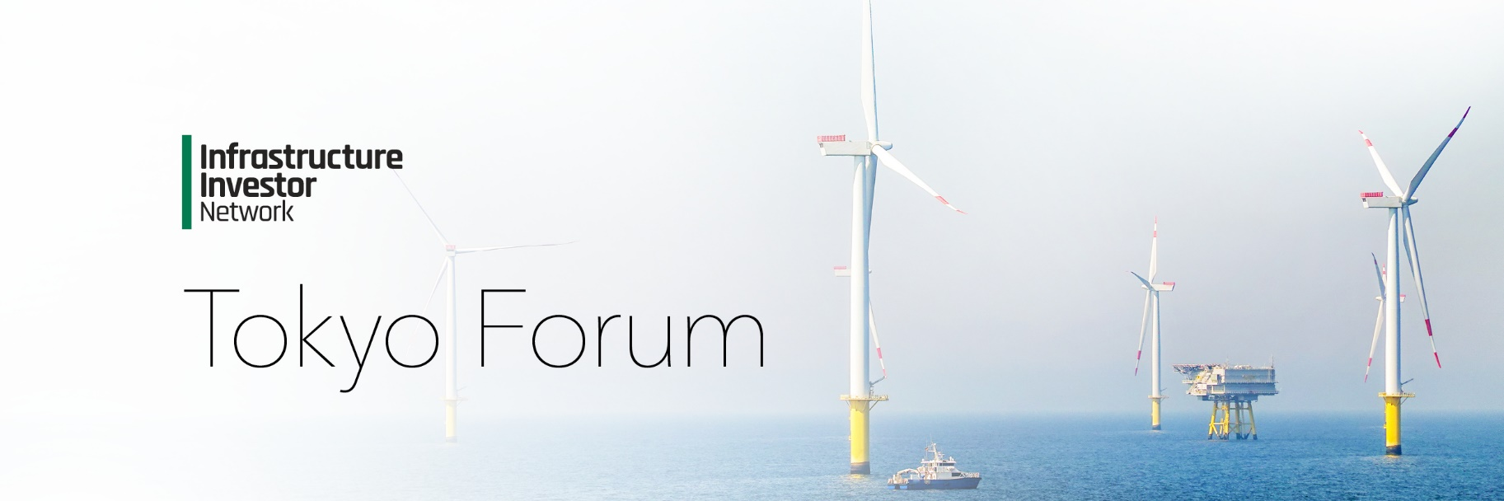

2025 Agenda

2024 Agenda

*Wednesday 4 June 2025*

08:30 – 09:00

**Registration and networking**

09:00 – 09:30

**Keynote presentation**

09:30 – 10:20

**Keynote panel: Infrastructure investing in a volatile world: balancing opportunities and geopolitical risks**

* In an increasingly unstable geopolitical landscape, how will infrastructure as an asset class fare compared to other private markets in 2025?
* Will ongoing geopolitical risks and volatility have tangible impacts on the renewables sector and its appeal as a subsector?
* Amid increasing concerns about over-paying for assets, how do GPs ensure they source the best deals?

George Theodoropoulos, Managing Partner, **Fengate Asset Management**

10:20 – 10:50

**Networking break**

10:50 – 11:40

**Panel: Renewables Platforms as an Investment Strategy**

* Europe vs US vs APAC – which global jurisdictions are proving the most attractive?
* How can investing in renewables platforms mitigate risk, diversify portfolios, and enhance scalability?
* Distributed energy vs. large-scale renewables: understanding the benefits and limitations of distributed energy systems versus large-scale renewable projects

11:40 – 12:00

**Presentation**

12:00 – 13:10

**Lunch and networking**

|  |  |
| --- | --- |
| **Stream A** | **Stream B** |
| 13:10 – 14:00  **Panel: The rise of digital infrastructure and AI**   * How can digital infrastructure investments be optimized to support the real-time data needs of AI, including advancements in data centers, high-speed networks, and edge computing? * What are the key investment opportunities for institutional investors in AI-driven infrastructure, such as smart cities, 5G networks, and energy management systems? * What strategies can investors use to balance regulatory, technological, and cybersecurity risks while maximizing returns in this rapidly evolving sector?   **Moderated by:** Will Fee, Researcher/Journalist, **Yuri Group** | 13:10 – 14:00  **Panel: Unlocking Value: the evolving landscape of infrastructure secondaries investment**   * How does investing in secondaries compare to primary infrastructure investments in terms of returns? * How is the nature of deals in the secondary infrastructure market evolving? * How are investors navigating liquidity, portfolio diversification, and the growing demand for secondary market transactions in private infrastructure deals?   **Moderated by:** Jingjing Bai, Senior Advisor, **Bfinance** |
| 14:00 – 14:50  **Panel: Spotlight on the US infrastructure market**   * In what sectors are decarbonization efforts increasing investment opportunities? * How will the new U.S. administration impact the investment climate, and what regulatory changes should investors be aware of? * Does the second Trump administration make renewables investment in the US harder? | 14:00 – 14:50  **Panel: Investing in infrastructure debt: a sector for all cycles**   * How does infrastructure debt offer resilience across economic cycles, and what characteristics make it an attractive option in the current period of geopolitical uncertainty? * Understanding the case for sub-investment grade strategies * Does appetite for infrastructure debt remain strong in a falling interest rate environment? |
| 14:50 – 15:30  **Panel: Driving sustainable strategies in infrastructure investing**   * Aligning sustainability with profitability, how can infrastructure investors balance the need for fair pricing with ambitious net zero goals? * How should infrastructure funds address physical and transition risks in their portfolios while seizing opportunities in renewables? * What’s the most effective way for infrastructure investors to engage with portfolio companies’ sustainability projects?   Cate Ambrose, CEO, **Global Private Capital Association**  Philip Kent, CEO, **Gravis**  Wakako Taniguchi, Executive Consultant, **Russell Investment**  **Moderated by:** Monica Bae, Director, **AIGCC** | 14:50 – 15:30  **Panel: Investing in global vs regional infrastructure funds**   * How do global infrastructure funds compare to regional ones in terms of diversification and risk management? * What are the potential return differences between investing in global versus regional infrastructure funds? * In what ways do regional funds offer unique opportunities for infrastructure investment that may be less accessible to global funds? Eg. accessing Asian investment opportunities.   Serkan Bahceci, Partner & Head of Research, **Arjun Infrastructure Partners** |

15:30 – 16:00

**Networking break**

16:00 – 16:30

**Presentation**

16:30 – 17:30

**Panel: The maturation of Japanese LPs’ investment strategies**

* As Japanese investment has grown, are we seeing greater sophistication in their investment strategies? Are closed-end funds gaining traction compared to the historically popular open-end funds?
* Are more Japanese LPs investing directly without gatekeepers, and will the role of gatekeepers remain central moving forward?
* How do Japanese investors view current geopolitical risks when making allocations?

Kenichiro Matsunaga, Director, Infrastructure Investment, **Japan Post Bank**

Tadasu Matsuo, Head of Alternatives, **JST**

Yasuaki Tojo, Vice President, **Development Bank of Japan**

Junichi Yonezawa, Head of Alternative Investments, **Norinchukin Zenkyoren Asset Management**

**Moderated by:** Takako Koizumi, Chief Investment Officer, Investment Management, **Mitsui & Co. Alternative Investments**

17:30

**Cocktail Reception**

*Thursday 5 June 2025*

08:30 – 08:50

**Infrastructure Investor membership breakfast briefing**

09:00 – 09:30

**Registration and networking**

09:35 – 09:55

**Keynote presentation**

Ryusuke Yoshida, Investment Lead, Infrastructure, **GPIF**

09:55 – 10:40

**Panel: Understanding the role of the strategic investor in the infrastructure market**

* How are strategic investors approaching investments in datacentres and renewables?
* What lessons have strategic investors learned from past investments in Japan's infrastructure, and how have these experiences shaped their current strategies?
* What roles do partnerships and collaborations play in the investment strategies of strategic investors within Japan's infrastructure sector and beyond?

**Moderated by:** Yasuhiko Hama, Managing Director, **Crosspoint Advisors**

10:40 – 11:10

**Networking break**

11:10 – 12:00

**Panel: The continuing evolution of the Japanese infrastructure market**

* What are the primary drivers behind the increasing demand for corporate PPAs in Japan, and how is this impacting the renewable energy market?
* Evaluating the outcomes of the second-round battery auction: does it bode well for future growth?
* How will government mandates shape the financial outlook for battery and energy storage companies in Japan?

Jose Antonio Millan Ruano, CEO, **Nozomi Energy**

Oliver Senter, **Shizen Energy**

**Moderated by:** Dan Shulman, Principal, **Shulman Advisory**

12:00 – 12:50

**Panel: Harnessing investment opportunities in the mid-market sector**

* Why does the mid-market provide more favorable exit dynamics and faster capital velocity compared to large-cap investments?
* Mid-market specialists vs. multi-strategy platforms – which investment strategies are the most compelling?
* Is there a risk that generalists in the mid-market could get squeezed out?

Achal Bhuwania, CIO, **Equitix**

12:50 – 13:50

**Lunch and networking**

13:50 – 14:00

**Close of conference**

*Friday 6 June 2025*

14:00

**Women in Real Assets networking function (Collocated with PERE Tokyo Forum)**