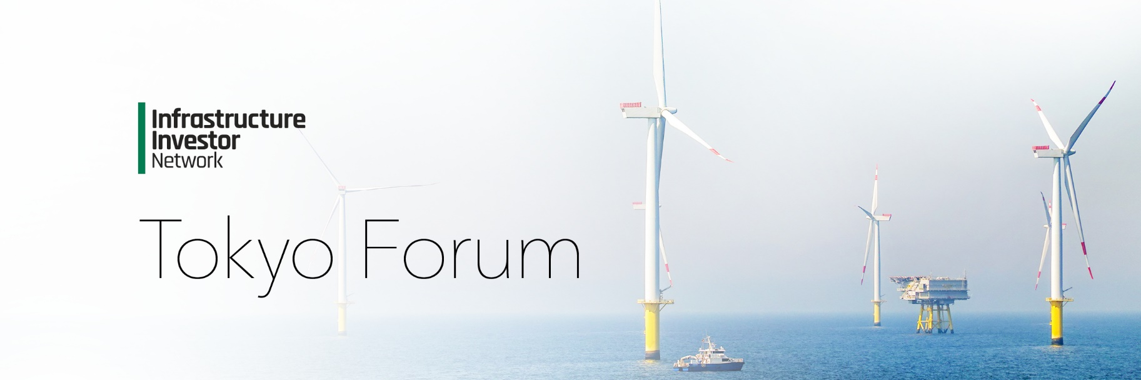

2025 Agenda

2024 Agenda

*Wednesday 4 June 2025*

08:30 – 09:05

**Registration and networking**

09:05 – 09:40

**Keynote presentation**

09:40 – 10:30

**Keynote panel: Infrastructure investing in a volatile world: balancing opportunities and geopolitical risks**

* In an increasingly unstable geopolitical landscape, how will infrastructure as an asset class fare compared to other private markets in 2025?
* Will ongoing geopolitical risks and volatility have tangible impacts on the renewables sector and its appeal as a subsector?
* Amid increasing concerns about over-paying for assets, how do GPs ensure they source the best deals?

**Moderated by:** Don Hung Jang, Senior Advisor, **Yulchon**

10:30 – 11:00

**Networking break**

11:00 – 11:50

**Panel: Renewables Platforms as an Investment Strategy**

* Europe vs US vs APAC – which global jurisdictions are proving the most attractive?
* How can investing in renewables platforms mitigate risk, diversify portfolios, and enhance scalability?
* Distributed energy vs. large-scale renewables: understanding the benefits and limitations of distributed energy systems versus large-scale renewable projects

**Moderated by:** Ayaka Fujiwara, Climate Investment Specialist, **Green Climate Fund**

11:50 – 12:10

**Presentation**

Ethan Koh, Head of Global Research Operations, **PEI Group**

12:10 – 13:10

**Lunch and networking**

13:10 – 14:00

**Panel: The rise of digital infrastructure and AI**

* How can digital infrastructure investments be optimized to support the real-time data needs of AI, including advancements in data centers, high-speed networks, and edge computing?
* What are the key investment opportunities for institutional investors in AI-driven infrastructure, such as smart cities, 5G networks, and energy management systems?
* What strategies can investors use to balance regulatory, technological, and cybersecurity risks while maximizing returns in this rapidly evolving sector?

14:00 – 14:20

**LP spotlight interview**

Interviewee: John Chang, Director, **CPPIB**

1420 – 15:10

**Panel: Harnessing investment opportunities in the mid-market sector**

* Why does the mid-market provide more favorable exit dynamics and faster capital velocity compared to large-cap investments?
* Mid-market specialists vs. multi-strategy platforms – which investment strategies are the most compelling?
* Is there a risk that generalists in the mid-market could get squeezed out?

Serkan Bahceci, Partner & Head of Research, **Arjun Infrastructure Partners**

Achal Bhuwania, CIO, **Equitix**

George Theodoropoulos, Managing Partner, **Fengate Asset Management**

15:10 – 15:40

**Networking break**

15:40 – 16:20

**Panel: Unlocking value: The evolving landscape of infrastructure secondaries investment**

* How does investing in secondaries compare to primary infrastructure investments in terms of returns?
* How are the nature of deals in the secondary infrastructure market evolving?
* How are investors navigating liquidity, portfolio diversification, and the increasing demand for secondary market transactions in private infrastructure deals?

16:20 – 17:05

**Panel: Navigating new horizons: Korean LPs expanding role in global infrastructure investment**

* What are the current key criteria for Korean LPs when selecting GPs and have they changed in the past 12 months?
* Which sectors are Korean investors bullish on? Are they increasing their digital infrastructure allocation?
* Do blind pool funds remain the default or are we seeing more appetite for co-investments and direct investing?

Hyungon Kim, Head of Infrastructure Team 1, **The Korean Teachers’ Credit Union**

**Moderated by:** Monica Bae, Director, **AIGCC**

17:05

**Cocktail Reception**